Professional Computing - CITS3200 Team 30

**Team Meeting #5**horizontal line

**Date:** 30/08 **/ Time:** 6pm **/ Location: Online (Teams)**

**Chair:** Edward Giles

**Minutes:** Alexia Fassetta

**Attendees:** J**o**rdan Lee, Zack Zou, Edward Giles, Alexia Fassetta, Jichunyang

**Apologies:** Nicodemus Ong

**Minutes Duration:** 45 mins

# The meeting was declared open at 6.00pm pm, quorum was present.

# The meeting was declared closed at 6.42 pm, quorum was present.

## **Confirmation of Previous Minutes**

**Motion:** “To accept the 28/08 minutes as true and correct”

**Moved:** Edward

Moved Unanimously / Moved by Majority

**AGENDA**

| Team Updates | All |
| --- | --- |
| Technical Review | All |
| Discuss project Management / Teamwork | All |
| Announcements | All |
| Upcoming Meetings: | All |

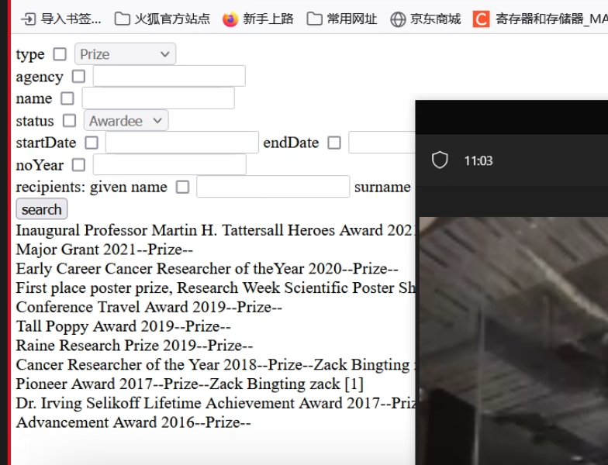

**MINUTES**

## 1.1 Team updates:

Zack

* Front end Querying functionality
* Multiple views
* Has uploaded data for testing
* Will continue to make modifications
  + Check box
  + rendering

Jordan

* Front end investigation
* Focused on appearance
* Spent time creating code but was deleted so has to start again

Edward & Nic

* Set up the table schema for the SQL Database
* Most the tables are in place
* There are certain fields in grants tables that require further information

Alexia

* Meeting minutes as Documentation to GitHub,
* Preparing productive agenda for our auditor meeting
* ETL cleaning on python.

## 1.2 Project Management Teamwork:

* Working as a team:
  + Communication and preparation has improved
  + Daily stand up meetings / daily tracking
  + Everyone to notify each other
    - What we have completed
    - Where we are struggling
    - Questions/ remarks
* Keep adding actionable items in the agenda
  + Tangilby setting these
    - Github time estimates
* Bring up suggestions before the meetings
* Source of truth of documents
  + Can't afford to have multiple documents of the same thing
  + Time expensive
  + Everyone to be aware of
* Be more critical of our time estimates/ milestones for our sprint 2 preparations and review

## 1.3 Further announcements:

Saturday Team meeting 12pm

* Agenda to include
  + Team Updates
  + Sprint 2 deliverables planning/ delegation of tasks

Email to Tanya

* Further requirement Analysis
* Everyone to provide queries as a request for further information

## 1.4 Actionable items:

* Jordan:
  + To compare AWS / Microsoft
    - Cost/ budgeting
    - Functions/ features
    - how to store the database
* ALL:
  + Tanya email
    - Send queries in word doc through email to Tanya
  + Set up a communication platform outside of teams
  + Technical knowledge about database and Cloud